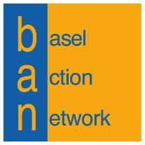

Donation Form

Please fill out the following form and return it along with your gift to:
Basel Action Network
206 1st Avenue South, Suite 410
Seattle, WA 98104
Or email to: donate@ban.org
Or go to: ban.org/give and give your gift online

Pledge
I pledge to give a gift of $
☐ one-time, or
☐ monthly, on the of the month, for $ per month
☐ Yes, my employer matches gifts ☐ Please follow up with me about employer matching

Contact Information
Name
Company name
Address
Email Phone

Payment Method
☐ Check (Payable to Basel Action Network)
☐ Credit Card (+ 3% processing fee) ☐ Visa ☐ MasterCard
Name on card
Card number
Expiration date Security code
For any questions, please contact Ashley Knapp at 206.652.5555 x107

Thank you for your generosity!

